Title of my CHNT Long Abstract <style CHNT_Title>
Subtitle of my CHNT Long Abstract <style CHNT_Subtitle>
FirstAuthorFirstName LastName, affiliation, country <style CHNT_Name_Affiliation>
SecondAuthorFirstName LastName, affiliation, country <style CHNT_Name_Affiliation>
<empty line, style CHNT_Text>
Keywords: Please add 3 to 5 key words separated by colons. <style CHNT_Text>
Guidelines <style CHNT_Heading 1>
General issues <style CHNT_Heading 2>
Please use Microsoft Word or a compatible free word processor using the styles described in the next section. Long abstracts must be written either in British or American English (the spelling should not be mixed). Please do not use endnotes but only footnotes using style CHNT_footnote. Use standard abbreviations for metric units (km, kg, m, etc.) without final full stops. Square metres should be expressed as m². Define non-trivial abbreviations and acronyms the first time they are used in the text.
Do not change the font sizes or line spacing to squeeze more text into the maximum number of pages which is 3 for long abstracts (all inclusive). The contribution’s word count inclusive of tables, references, and figure captions should be above 800. Remember to check spelling. If your native language is not English, please get a native English-speaking colleague to carefully proofread your text.
By submitting a long abstract you agree that this contribution may be published under the terms of the CC BY-NC-ND 3.0 Licence in the CHNT proceedings (In case of submitting as “short paper”, “Round Table paper” or “Poster”). Please provide your long abstract as word document (.doc or .docx) and in addition as a PDF file without names, affiliations, countries, addresses, and emails for the review process. All submissions will be subject to a single round of academic refereeing after submission. It is therefore possible that your submission is rejected or you will be asked to make some changes to your long abstract before it is published. <style CHNT_Text>
Tables and Styles <style CHNT_Heading 2>
Please make strict use of the given styles that have been carefully defined for each part of the long abstract, listed in Table 1.
When assigning a style to a particular element of the paper, first select the section of text that you want to designate with a particular style and then select the appropriate style from the style menu. The style will then adjust your fonts and line spacing. Do not change the font sizes or line spacing to squeeze more text into the maximum number of pages. Please follow this rule carefully: it makes the final shape of your paper more uniform and makes production work easier. To highlight words, use italic letters only.
Style | Text involved
CHNT_Title | Title of the long abstract; Arial, 14 pt, bold, space before 24 pt, after 12 pt
CHNT_Subtitle | Subtitle, i.e. a secondary or explanatory title; Arial, 12 pt, bold, space before 0 pt, after 12 pt
CHNT_Name_Affiliation | Author’s name, short affiliation, country, immediately below the paper title;  Arial, 9 pt, spacing 0 pt before and after each paragraph, line spacing: multiple 1.15
CHNT_Heading 1 | Section title, level 1; Arial, 12 pt, bold, no numbering, space before 12 pt, after 0 pt
CHNT_Heading 2 | Section title, level 2; Arial, 11 pt, bold, no numbering, space before 11 pt, after 2 pt
CHNT_Text | Main body of the long abstract; Arial, 10 pt, spacing 4 pt before and after each paragraph, line spacing: multiple 1.15
CHNT_Table_Header | Header of a table column; Arial, 8 pt, bold, spacing 10 pt before and 3 pt after each paragraph
CHNT_Table | Cells of the table; Arial, 8 pt, spacing 2 pt before and after each paragraph
CHNT_Captions | Figure or table caption, below the figure or table; Arial, 9 pt, italics, spacing 4 pt before and 10 pt after each paragraph, line spacing: multiple 1.15, centre align
CHNT_SubfigureLetter | Arial, 10 pt, italics, spacing 2 pt before and 6 pt after each paragraph
CHNT_Footnote | Author’s address and footnotes; Arial, 8 pt, spacing 0 pt before and after each paragraph, line spacing: single, spacing 2 pt after each paragraph
CHNT_Reference | Entry in the list of references at the end of the paper; Arial, 9 pt, spacing 4 pt before and 4 pt after each paragraph, line spacing: multiple 1.15, hanging: 0.5 cm
Table 1. List of the styles used in a CHNT long abstract.
The Style CHNT_Footer is only used for the page numbers at the bottom of each page.
Please use footnotes instead of endnotes.
Tables should be numbered according to the order in which they first appear. Please ensure you cite each table in your text. Below each table, captions including text beyond the table name are mandatory.
Figures <style CHNT_Heading 2>
Please insert 1 to 3 figures in the text layout. Figures are supposed to fill the entire page breadth, like Fig. 1 or to be centred in the page, like Fig. 2. As an alternative, a figure can be made by different subfigures. In that case please indicate with a letter each subfigure, and make reference to it in the caption, as for example in Fig. 3 using style CHNT_SubfigureLetter. Figures should be numbered according to the order in which they first appear. Please ensure you cite each figure in your text.
Authors must obtain permission to publish illustrations taken from a copyrighted source. The figure caption should include the appropriate credit information.
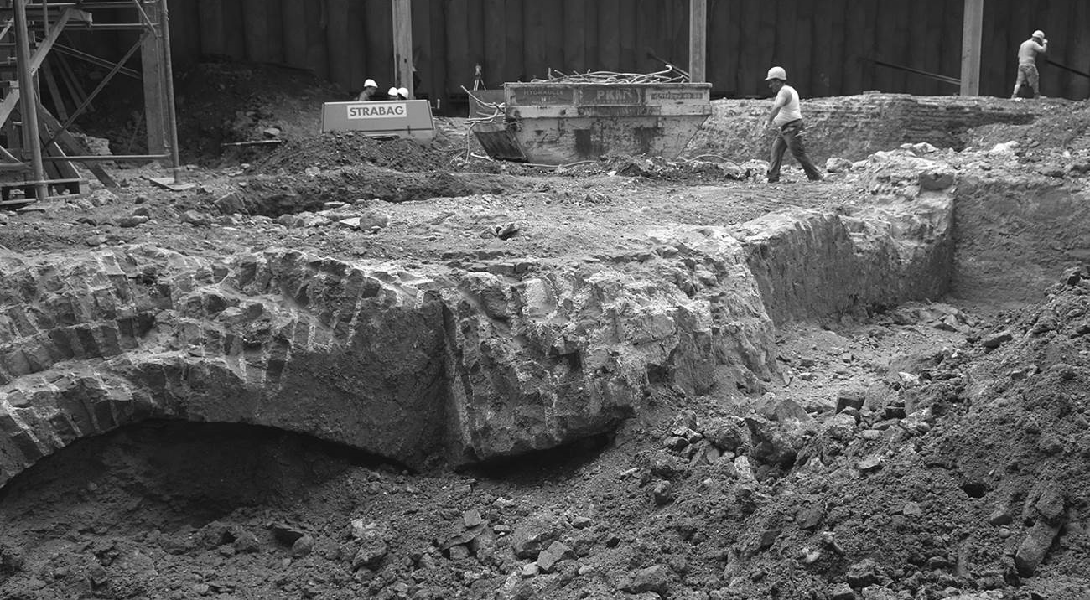
Fig. 1. Excavation, Mölker Bastei Vienna (© Stadtarchäologie Wien).

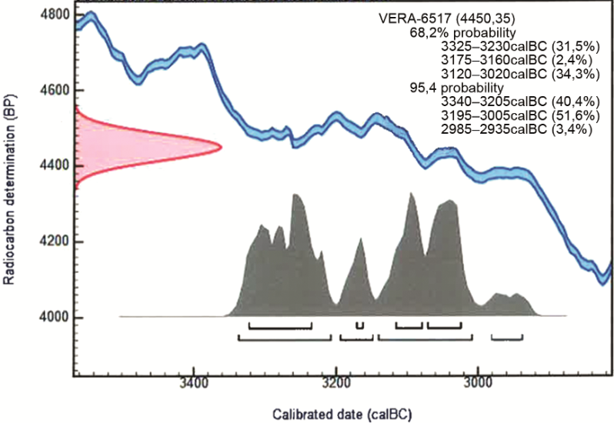
Fig. 2. Results of the Radiocarbon dating.
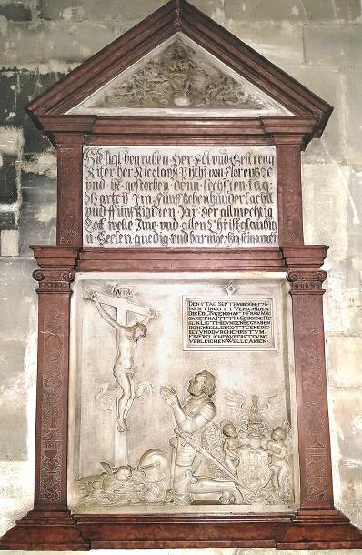  a | b | c
Fig. 3. Epitaph of Niclas Pitti, St. Stephans Cathedral Vienna a) f 2,6; b) f 4,8; c) f 12,9 (© Wolfgang Börner).
References in the text
Please use the Harvard Manchester style as a referencing system: http://subjects.library.manchester.ac.uk/referencing/referencing-harvard
Three to five references are mandatory, using the style CHNT_Reference. The citation of the paper by Boasson and Visser (2017) provides a template for citing a Studies in Digital Heritage publication. Polig (2016) published in a CHNT proceedings.
References
Boasson, W. and Visser, R. M. (2017). ‘SIKB0102: Sychronising Excavation Data for Preservation and Reuse’, Studies in Digital Heritage, 1(2), pp. 206-224. DOI:10.5284/1046734
Polig, M. (2016). The original Holy Cross Church in Dalby. New interpretations through digital archaeology, Proceedings of the 20th International Conference on Cultural Heritage and New Technologies 2015, Vienna, 17 pages. Available at https://www.chnt.at/wp-content/uploads/eBook_CHNT20_Polig_2015.pdf (Accessed: 13 January 2019).

 Author's address: Susanne Uhlirz, Urban Archaeology Vienna, Obere Augartenstraße 26-28, 1020 Vienna, Austria; email: susanne.uhlirz@stadtarchaeologie.at.
Footnotes concerning a single word should be positioned direktly after word.
Footnotes concerning a whole sentence should be positioned after the full stop. In-text references must not be written in footnotes.

